## MODULE 1- 7.1

# 1 QUESTION

**PROGRAM CODE:**

public class Shape {

private int numSides;

private boolean regular;

public Shape() {

this.numSides = 0;

this.regular = false;

}

public Shape(int numSides, boolean regular) {

this.numSides = numSides;

this.regular = regular;

}

public int getNumSides() {

return numSides;

}

public void setNumSides(int numSides) {

this.numSides = numSides;

}

public boolean isRegular() {

return regular;

}

public void setRegular(boolean regular) {

this.regular = regular;

}

public static void main(String[] args) {

Shape shape1 = new Shape();

Shape shape2 = new Shape(4, true);

System.out.println("Shape1 - Sides: " + shape1.getNumSides() + ", Regular: " + shape1.isRegular());

System.out.println("Shape2 - Sides: " + shape2.getNumSides() + ", Regular: " + shape2.isRegular());

shape1.setNumSides(3);

shape1.setRegular(true);

System.out.println("Shape1 after update - Sides: " + shape1.getNumSides() + ", Regular: " + shape1.isRegular());

}

}

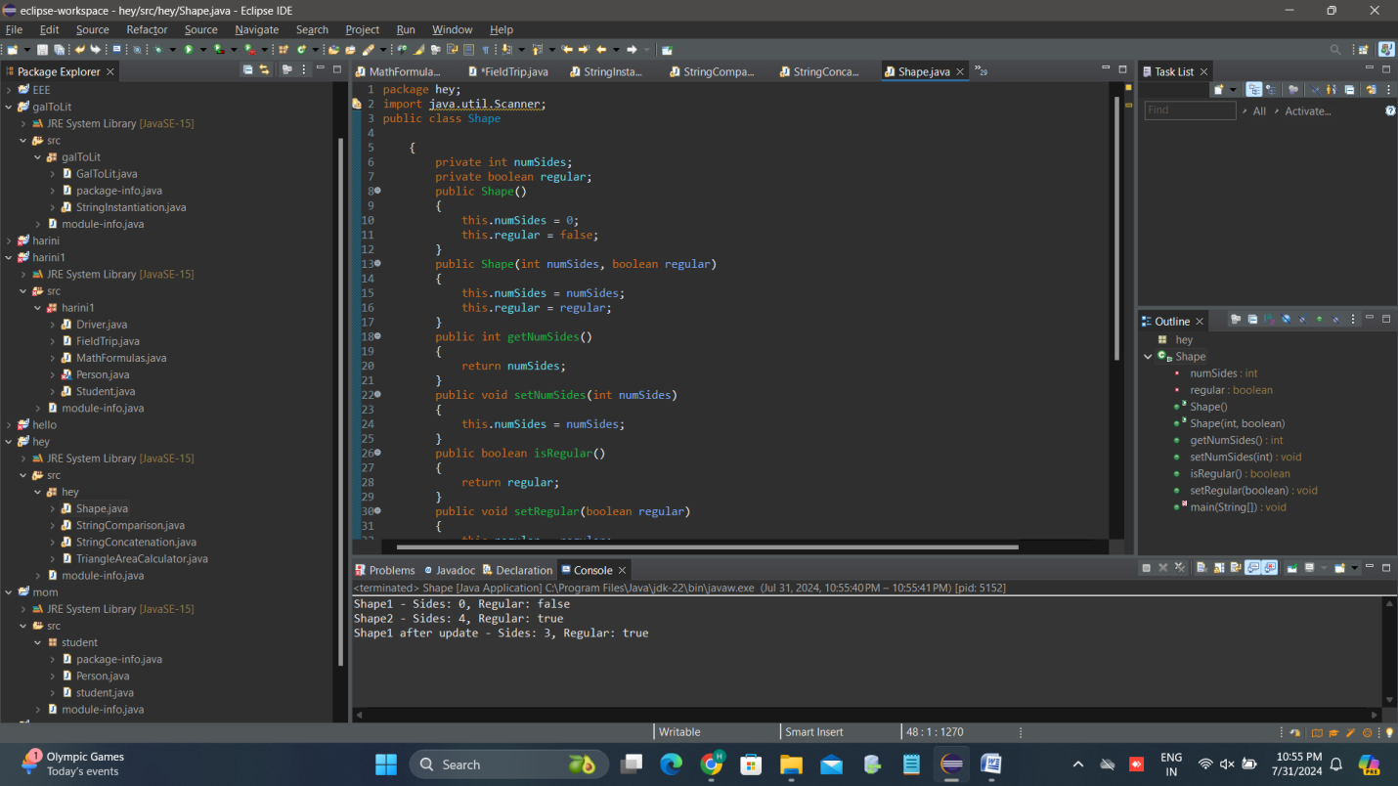

# 2 QUESTION

**PROGRAM CODE:**

public class Animal {

private int weight;

private int height;

private double speed;

public Animal() {

weight = 50;

height = 4;

speed = 2;

}

public Animal(int w, int h, double s) {

weight = w;

height = h;

speed = s;

}

public double getTime(double miles) {

return miles / speed;

}

public int getWeight() {

return weight;

}

public int getHeight() {

return height;

}

public double getSpeed() {

return speed;

}

}

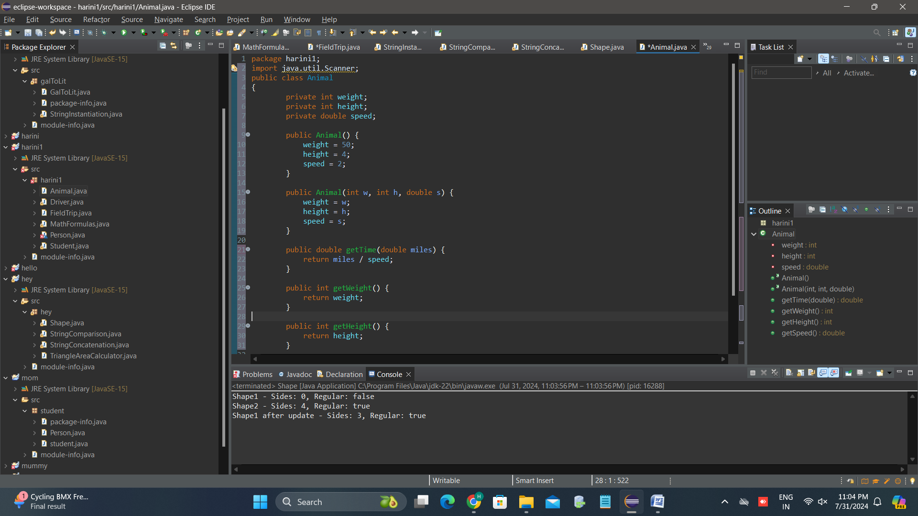

# 3 question

**PROGRAM CODE:**

package hey;

import java.util.Scanner;

public class Main

{

public static void main(String[] args) {

Animal animal1 = new Animal();

Animal animal2 = new Animal(75, 5, 10.0);

System.*out*.println("Animal #1 has a speed of " + animal1.getSpeed() + ".");

System.*out*.println("Animal #2 has a speed of " + animal2.getSpeed() + ".");

}

}

# 4 QUESTION

PROGRAM CODE:

package hey;

import java.util.Scanner;

public class Student

{

private String name;

private int credits;

private double gpa;

private double qualityPoints;

public Student(String name, int credits, double qualityPoints) {

this.name = name;

this.credits = credits;

this.qualityPoints = qualityPoints;

this.gpa = calculateGPA();

}

public double getGPA() {

return calculateGPA();

}

public void updateRecords(int newCredits, double newQualityPoints) {

credits += newCredits;

qualityPoints += newQualityPoints;

gpa = calculateGPA();

}

private double calculateGPA()

{

if (credits == 0)

{

return 0.0;

}

return qualityPoints / credits;

}

public String getName()

{

return name;

}

public int getCredits() {

return credits;

}

public double getQualityPoints() {

return qualityPoints;

}

}

# 5 QUESTION

PROGRAM CODE:

public class Main {

public static void main(String[] args) {

Student student1 = new Student("Mary Jones", 14, 46);

Student student2 = new Student("John Stiner", 60, 173);

Student student3 = new Student("Ari Samala", 31, 69);

System.out.println("Student 1: " + student1.getName() + ", Credits: " + student1.getCredits() + ", Quality Points: " + student1.getQualityPoints() + ", GPA: " + student1.getGPA());

System.out.println("Student 2: " + student2.getName() + ", Credits: " + student2.getCredits() + ", Quality Points: " + student2.getQualityPoints() + ", GPA: " + student2.getGPA());

System.out.println("Student 3: " + student3.getName() + ", Credits: " + student3.getCredits() + ", Quality Points: " + student3.getQualityPoints() + ", GPA: " + student3.getGPA());

}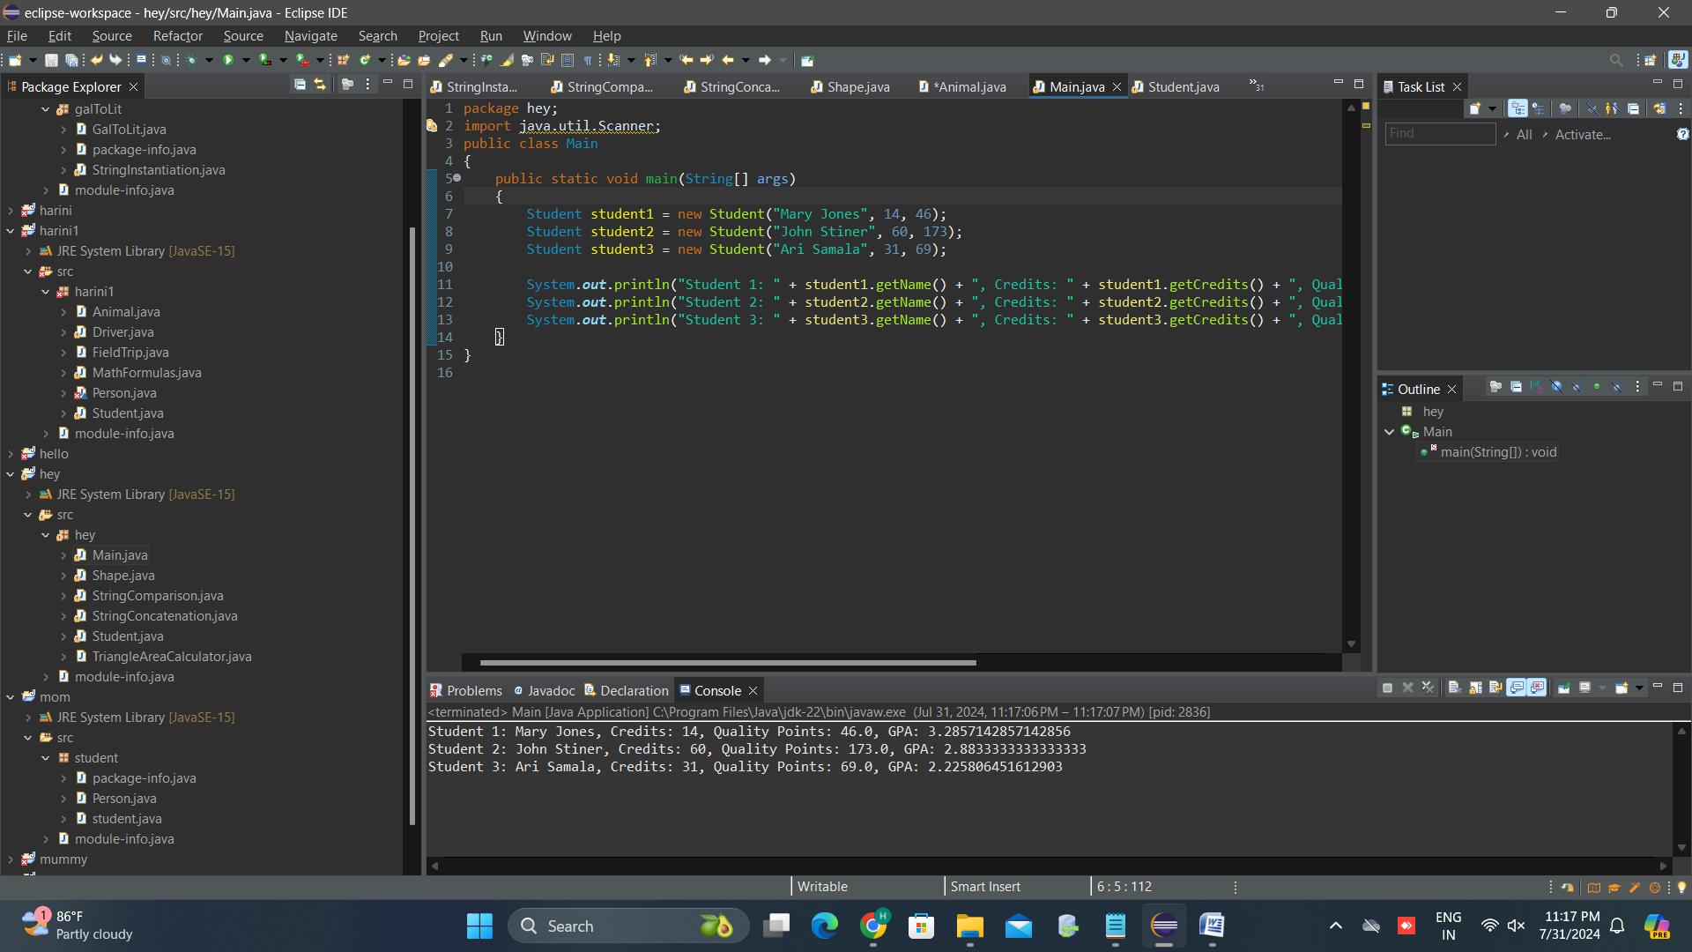

# 6 QUESTION

PROGRAM CODE:

import java.util.Scanner;

import java.util.ArrayList;

import java.util.List;

import java.util.Random;

public class Main

{

public static void main(String[] args)

{

Scanner scanner = new Scanner(System.***in***);

Random random = new Random();

List<Integer> hand = new ArrayList<>();

int totalPoints = 0;

for (int i = 0; i < 2; i++) {

int cardValue = random.nextInt(10) + 1;

hand.add(cardValue);

totalPoints += cardValue;

}

System.***out***.println("Initial cards: " + hand);

System.***out***.println("Total points: " + totalPoints);

while (totalPoints <= 21 && hand.size() < 5) {

System.***out***.print("Would you like another card? (yes/no): ");

String response = scanner.nextLine();

if (response.equalsIgnoreCase("yes")) {

int newCardValue = random.nextInt(10) + 1;

totalPoints += newCardValue;

System.***out***.println("New card: " + newCardValue);

System.***out***.println("Hand: " + hand);

System.***out***.println("Total points: " + totalPoints);

} else {

break;

}

}

if (totalPoints > 21) {

System.***out***.println("Busted! Total points: " + totalPoints);

} else if (hand.size() == 5) {

System.***out***.println("Maximum number of cards reached. Total points: " + totalPoints);

} else {

System.***out***.println("Final hand: " + hand);

System.***out***.println("Final total points: " + totalPoints);

}

scanner.close();

}

}

